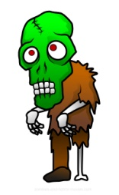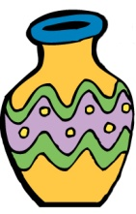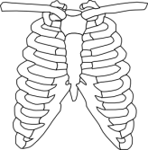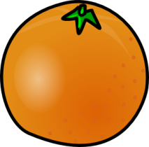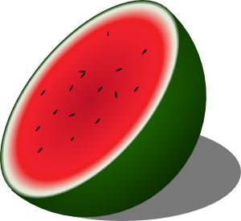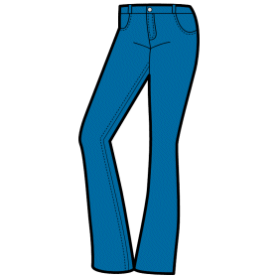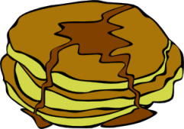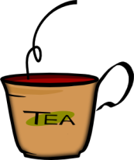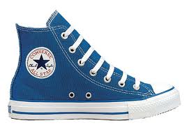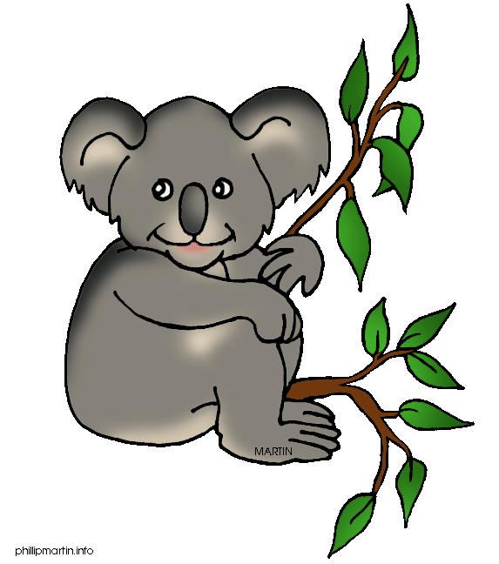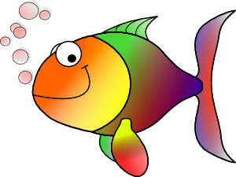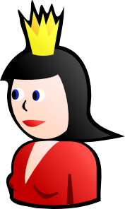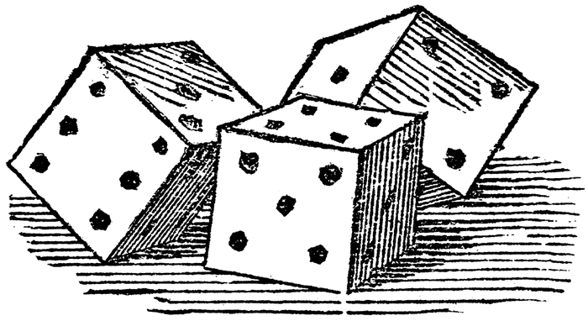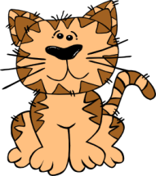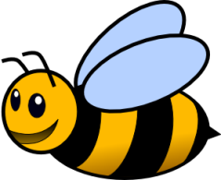

**GAME: Line Jump**

Students line up behind each other.When the teacher says a consonant, children jump to the right and back to the center. When the teacher calls a vowel, children jump to the left and back to center. Children who go to the wrong side are out. The one to be the last is the winner of the game.

Z

Y

X

W

V

U

T

S

R

Q

P

O

N

M

L

K

J

I

H

G

F

E

D

C

B

A

**An activity to be used with the alphabet and the body themes. It combines the two themes:**

**If Your Name Starts With�**  
(Tune of "If You're Happy and You Know It")  
  
If your name starts with A, turn around.  
If your name starts with B, touch the ground.  
If your name starts with C, then stand up and touch your knee.  
Clap your hands if your name starts with D.  
If your name starts with E, wink your eye.  
If your name starts with F, try to fly.  
If your name starts with G, blow a kiss up here to me.  
If your name starts with H, say "Hee, Hee".  
If your name starts with I, tap your toe.  
If your name starts with J, say "Ho, Ho".  
If your name starts with K, then stand up and start to sway.  
If your name starts with L, say "Hurray".  
If your name starts with M, make a smile.  
If your name starts with N, shake awhile.  
If your name starts with O, put your elbow on your toe.  
If your name starts with P, say "I know!"  
If your name starts with Q, raise your hand.  
If your name starts with R, you should stand.  
If your name starts with S, you should pat your head, I guess.  
If your name starts with T, say "Oh, yes!"  
If your name starts with U, touch your eye.  
If your name starts with V, pat your thigh.  
If your name starts with W, X, Y or Z,  
Then stand up, take a bow, and say "That's me!"